Name: ____________________________________

Date: ________________

Series Circuit Voltage Drop Quiz

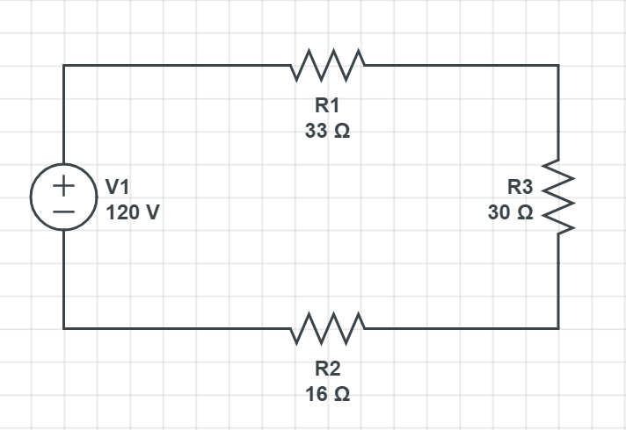

1. Using the schematic above, calculate the voltage drop at each resistor:

R1: _________

R2: _________

R3: _________

1. Indicate (draw) on the schematic what direction current is flowing.